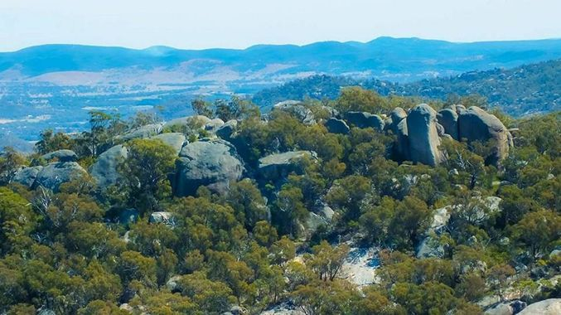
Girraween National Park. Contributed
NEWS

Why region's nationals parks could be opened for ecotourism
by TOM GILLESPIE
29th Dec 2017 9:00 AM

A VETERAN tourism expert in Toowoomba has named four national parks across the Darling Downs that could be opened for ecotourism.
Former Tourism and Events Queensland board member John Osborne, who advised several state governments in a career spanning three decades, welcomed calls from the current TEQ boss Brett Godfrey for Labor to allow eco-resorts, accommodation and attractions in national parks.
He liked the idea because he suggested it in the 1980s with the Queensland Tourist Industry Council, which he was the director.
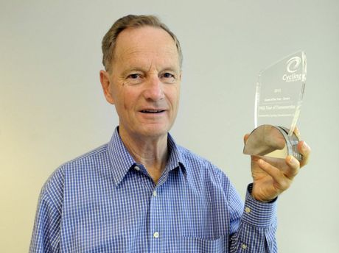
John Osborne.Bev Lacey
"The idea came from discussions around the board table (and) at that point in time, national parks were not appreciated, in the sense they were considered sacrosanct," he said.
"They were never seen as a tourism product.
"But as a board we saw the fact there was an opportunity to develop accommodation in harmony with the surrounding environment.
"They (the Bjelke-Petersen Government) were afraid of putting the community offside, because the notion of having people in there was not considered."
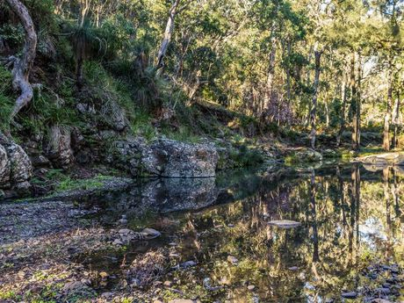
Beautiful still waters at Goomburra.Steven Kasper
Mr Osborne, who won an individual prize at the Queensland Tourism Awards in 2013, picked out Goomburra, Girraween, Crows Nest and the Bunya Mountains as national parks that should be investigated for tourism.
But he stressed that not all parks were suited to ecotourism.
"Not every national park lends itself to this," Mr Osborne said.
"I'm not suggesting we throw the lot of them open - some of them are unsuitable (but) let's have some vision and look to utilise them for ecotourism.
"Our belief is those for that actually benefit from these developments, there needs to be a structure where money is earned and goes back into the development of the parks, to supplement the cost to the government."
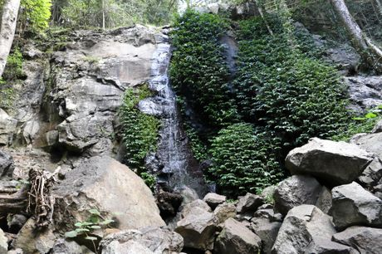
Bunya Mountains, Festoon Falls walking trail at Dandabah.Tom Threadingham
On top of catering for families, Mr Osborne said attractions at parks could appeal to specialist tourists like caravaners, bird-watchers and adventurers.
TEQ chairman Brett Godfrey will meet with new Environment Minister Leeanne Enoch to discuss opening up tourism opportunities at national parks.
The practice is big business in the United States and New Zealand, but is not utilised here.
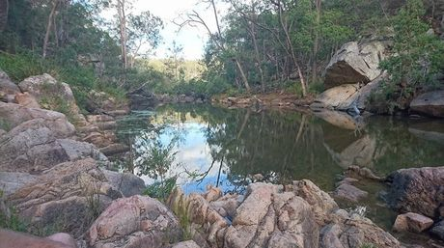
Crows Nest National Park.Cassy Noonan

ecotourism toowoomba tourism and events queensland

